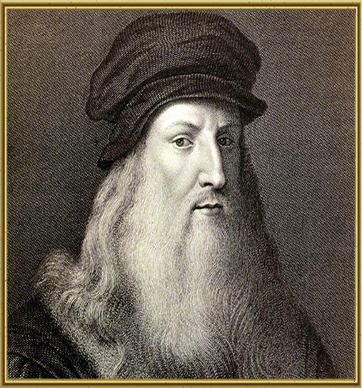
Leonardo da Vinci
(1452-1519)
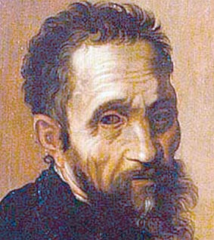
Michelangelo
(1475-1564)
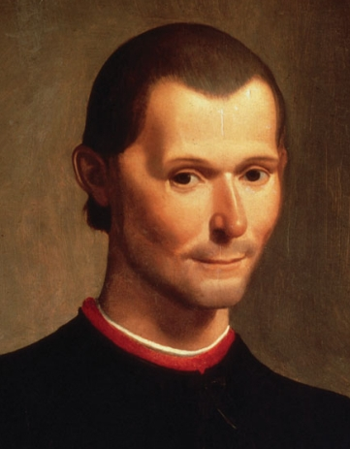
Machiavelli
(1469-1527)
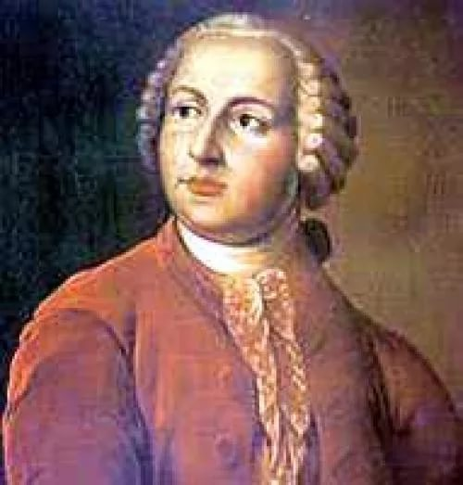
Mikhail Lomonosov
(1711-1765)
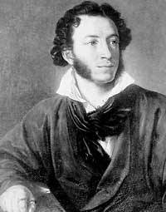
Alexander Pushkin
(1799-1837)
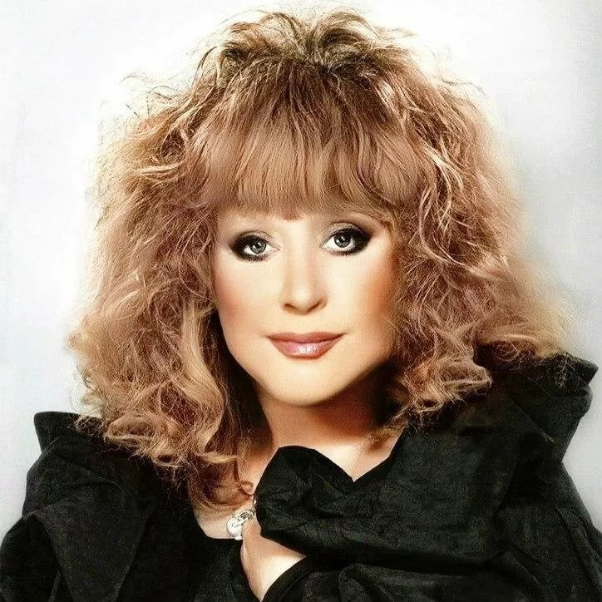

artist
genius
reporter
famous
Well done.
Anyway, …
from Italy
from Russia
sculptor
artist
architect
poet
scientist
musician
engineer
inventor
anatomist
botanist
writer
died in 1564
died in1765
died in 1837
died in 1519

